
THE UNIVERSITY OF DODOMA
COLLEGE OF INFORMATICS AND VIRTUAL EDUCATION

GROUP ASSIGNMENT
MODULE NAME | : | DATA STRUCTURE AND ALGORITHMS ANALYSIS
MODULE CODE | : | CP 213
FACILITATOR | : | Mr. MAHENGE
SEMESTER | : | ONE
ACADEMIC YEAR | : | 2025 / 2026
PARTICIPANTS
S/N | NAME | REG NUMBER | PROGRAMME
1 | MARIAM MOHAMED SLIM | T24-03-19263 | BSC-CS
2 | ELISHA MOSES MDEGELA | T24-03-16974 | BSC-CS
3 | BEATUS LEVERIAN | T23-03-15570 | BSC-CS
4 | MICHAEL FRANK NKWAMA | T24-03-10329 | BSC-CS
5 | ABRAHAM SAID KALEMBO | T24-03-25084 | BSC-CS
6 | JACKLINE MASANJA YATABU | T24-03-25773 | BSC-CS
7 | ALLY JABIRI JAHA | T24-03-23599 | BSC-CS
8 | ALHAMDU YASSIN | T24-03-17984 | BSC-CS
9 | KELVIN EVAREST SULLE | T24-03-25232 | BSC-CS

Question One
a. Regarding figure 1:
i. Level order traversal : 8 5 4 9 1 12 7 11 3
ii. Inorder traversal : 9 5 1 12 8 7 4 11 3
iii. Postorder traversal : 9 1 12 7 11 3 5 4 8
iv. Preorder traversal : 8 5 9 1 12 4 7 11 3

b. Regarding figure 2:
i. Depth First Search(DFS) : A B C D E
ii. Breadth First Search(BFS) : A B C E D

c. Programming concepts used:
i. BFS : Queue
ii. DFS : Stack

Question Two
a. Managed flee the prison
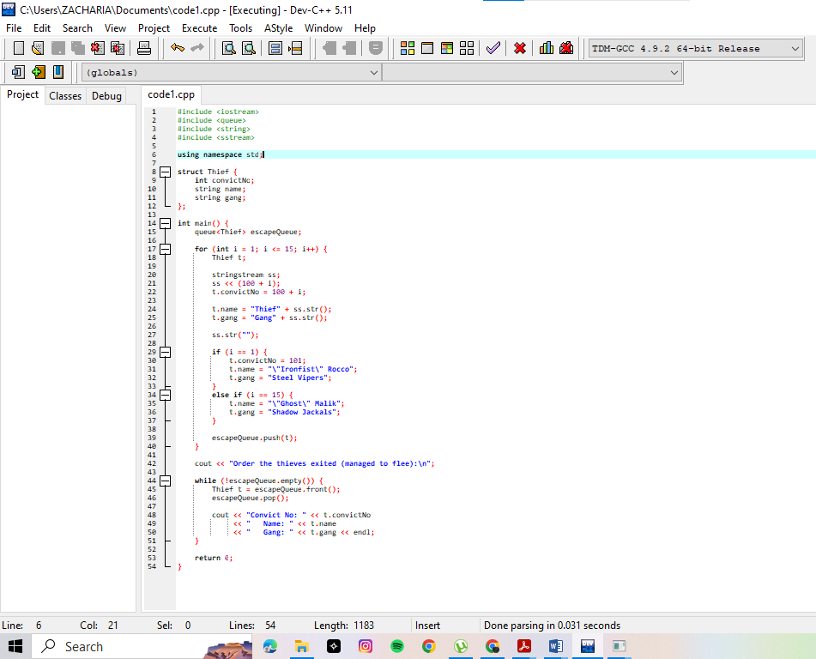
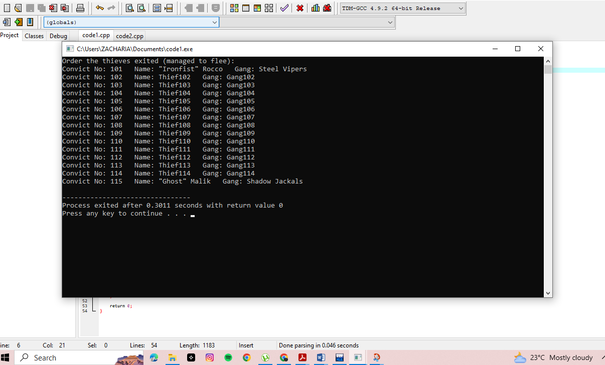

b. Failed to flee from the prison

